Eisteddfod by the Bay
Pianoforte
Adjudicator 2017: Mr Len Vorster
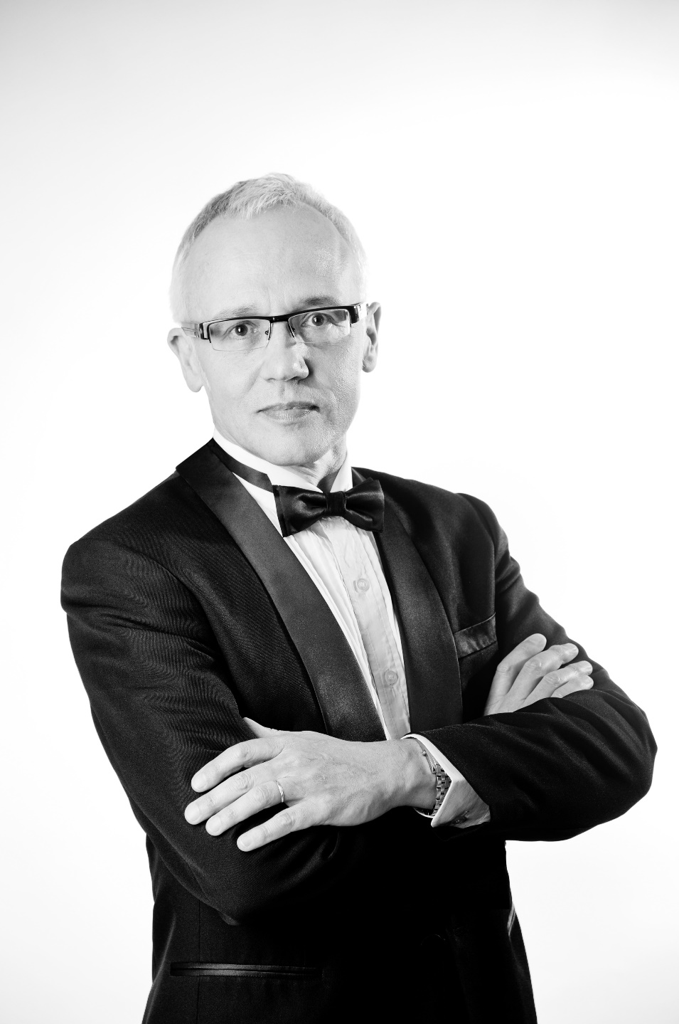 | Len Vorster left South Africa for Australia in 1983 after completing postgraduate piano studies with the eminent pianist Lamar Crowson at the University of Cape Town. He made his concerto debut with the Cape Town Symphony Orchestra in Mozart's Piano Concerto K456 in 1976. As a concerto soloist he has recorded Michael Easton's Concerto on Australian Themes with the State Orchestra of Victoria for Naxos (conducted by Brett Kelly), and gave first performances of the work in Italy, Hungary, Germany, and with the Royal Academy Orchestra in London in 2001. He has performed with the Melbourne Musicians conducted by Frank Pam, the Heidelberg Symphony Orchestra conducted by Chris Kopke, and with the Geelong Chamber Orchestra conducted by Stephen Roth. His Naxos recording of Holst's The Planets (two-piano version with Robert Chamberlain) has received a Gramophone Magazine award.
With Merlyn Quaife, he has been nominated for an Aria award for his Naxos recording of music by Manuel de Falla. Len Vorster has recorded with Ian Partridge the complete songs and solo piano music of Lord Berners for Marco Polo.
In 2003 he released a solo CD Summer Waves, and ABC Classics released two CDs of Brahms Clarinet Chamber Music with Len Vorster, Deborah de Graaff and Georg Pedersen. In 2005 Naxos released his CD of solo piano and chamber music of Lennox Berkeley. A further Naxos CD of music of Samuel Barber was released in August 2006. In 2009 Move Records released Burns and Beyond with soprano Vivien Hamilton, and 2010 saw a Tall Poppies release of a Barber and Debussy with David Berlin and Len Vorster. In 2017 he is recording his second CD with Vivien Hamilton.
In 2001 he formed a duo with David Berlin, Principal Cellist of the Melbourne Symphony Orchestra. The Berlin Vorster Duo toured Taiwan in 2003 and their CD Reflections was re-released for the Taiwan market. Len Vorster regularly performs with La Prima (directed by Alison Rae Jones) and with Promac Productions (directed by Chris McKenna). He is the founding Artistic Director of Port Fairy Spring Music Festival, and is currently on the piano staff at Monash University, the University of Melbourne, and Victorian College of the Arts Secondary School.
From 1980 - 1982 Len Vorster was on the piano staff and official accompanist at the Faculty of Music, University of Cape Town, South Africa. He is also a regular examiner in Taiwan for the International Piano Performance Committee, and is chairman of IPPEC. Most recently he has adjudicated the Hobart Eisteddfod and the Eisteddfod by the Bay, Melbourne.
www.lenvorster.com.au

